Travel Bingo
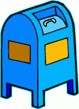  Public Mailbox | 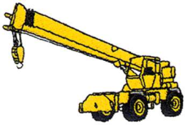  crane | beer bottle | 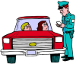  someone getting pulled over | 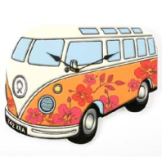  van with art  on the side
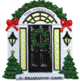  house with a black door | Baseball cap | F  The letter F | 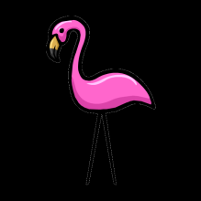  Yard Statues | 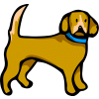  Dog
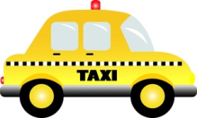  taxi | 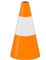  traffic cone | Free | 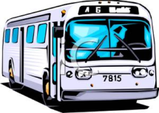  Bus | 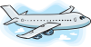  airplane
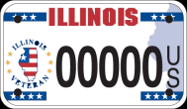  Out-of-State License Plate | 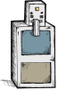  newspaper  stand | 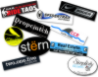  bumper sticker | 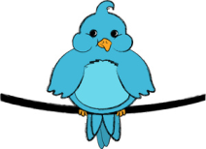  Bird on a Wire | birdbath
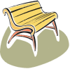  bench | 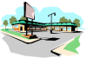  strip mall | 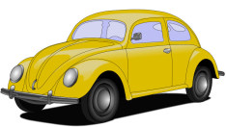  Volswagen Beetle | 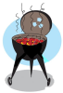  Grill | 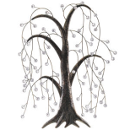  weeping  willow tree
if the dog is barking, take a free spot
if the strip mall has a beauty salon, force another player to uncover a spot

